EV3 scanner

I sorted source/destination, protocol, length and info separately.

Then, I found that when info section is “Rcvd UIH Channel=1”, the data section looks almost the same for each packet, beside of some are “00 40”, some are “80 3f”. Seeing that it's a scanner on the white paper with black strokes, I deduced that’s the signal when scanning white and black. Moreover, it’s kinds of a car to scan, when meeting the end, the car reversed.(like S track)

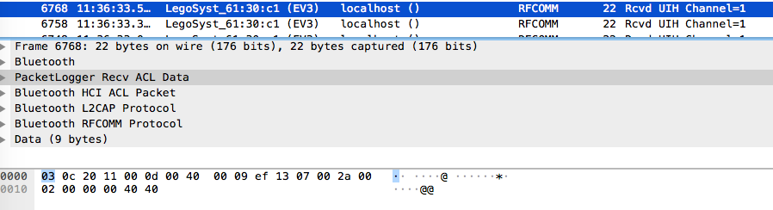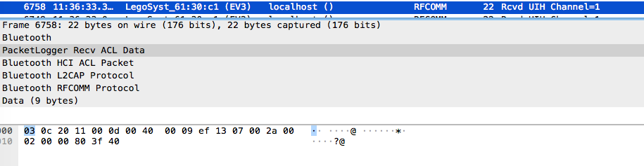

|  |
| --- |
| #different line  flagl0 = ""  flagl1 = ""  flagl2 = ""  ...  for i in range(0, len(data)):  temp = "".join(data[i]["_source"]["layers"]["data"]["data.data"].split(":"))  #turn  if turn == 0:  flagl0 += " "  elif turn == 1:  flagl1 += " "  ....    #put on mark  if detect == '80' and detect == '00':  if turn == 0:  flag10 += "#"  elif turn == 1:  flag11 += "#"  ....  print (flag10)  print (flat11)  ... |